**DAILY ONLINE ACTIVITIES SUMMARY**

|  |  |  |  |  |  |  |  |  |
| --- | --- | --- | --- | --- | --- | --- | --- | --- |
| **Date:** | **20/05/2020** | | | | | **Name:** | **PRANEETA P HANDRAL** | |
| **Sem & Sec** | **4​th​ SEM. & ‘B’ SEC.** | | | | | **USN:** | **4AL19CS401** | |
| **Online Test Summary** | | | | | | | | |
| **Subject** | | **OBJECT ORIENTED CONCEPTS** | | | | | | |
| **Max. Marks** | | **30** | | **Score** | | | **19** | |
| **Certification Course Summary** | | | | | | | | |
| **Course** | **Python for Machine Learning** | | | | | | | |
| **Certificate Provider** | | | **Greatlearning academy** | | **Duration** | | | **5 Hrs.** |
| **Coding Challenges** | | | | | | | | |
| **Problem Statement:** **Write a C or Java program to implement FCFS and SJF process scheduling.**  **Input: Processes with burst time**  **Output: Process being scheduled**  **Problem Statement:** **Write a C Program to Reverse a Linked List (SLL) in groups of given size.** | | | | | | | | |
| **Status:** **Executed.** | | | | | | | | |
| **Uploaded the report in Github** | | | | | **Yes** | | | |
| **If yes Repository name** | | | | | **LockdownCoding** | | | |
| **Uploaded the report in slack** | | | | | **Yes** | | | |

**Online Test Summary:​** 18CS45 online test was scheduled from 9:30 am t0 10:10 am .The portion for the IA was 1st module, the questions were MCQ type.

**Online Certification course Summary​:** Today I’ve gone through Jupyter notebook shortcuts and also gone through the data structure in Payton .

**There are main four shortcuts :**

● Shift + Enter

● Ctrl + Enter

● Tab

● Shift + Tab Shift + Enter -> runs the cell and goes to the next cell.

Ctrl + Enter -> runs and stays in the current cell.

Tab -> tab-completion is done by dropdown menu.

Shift + Tab -> gives the description of the function and tells actually how that function works.

It is shown in the below snapshot.

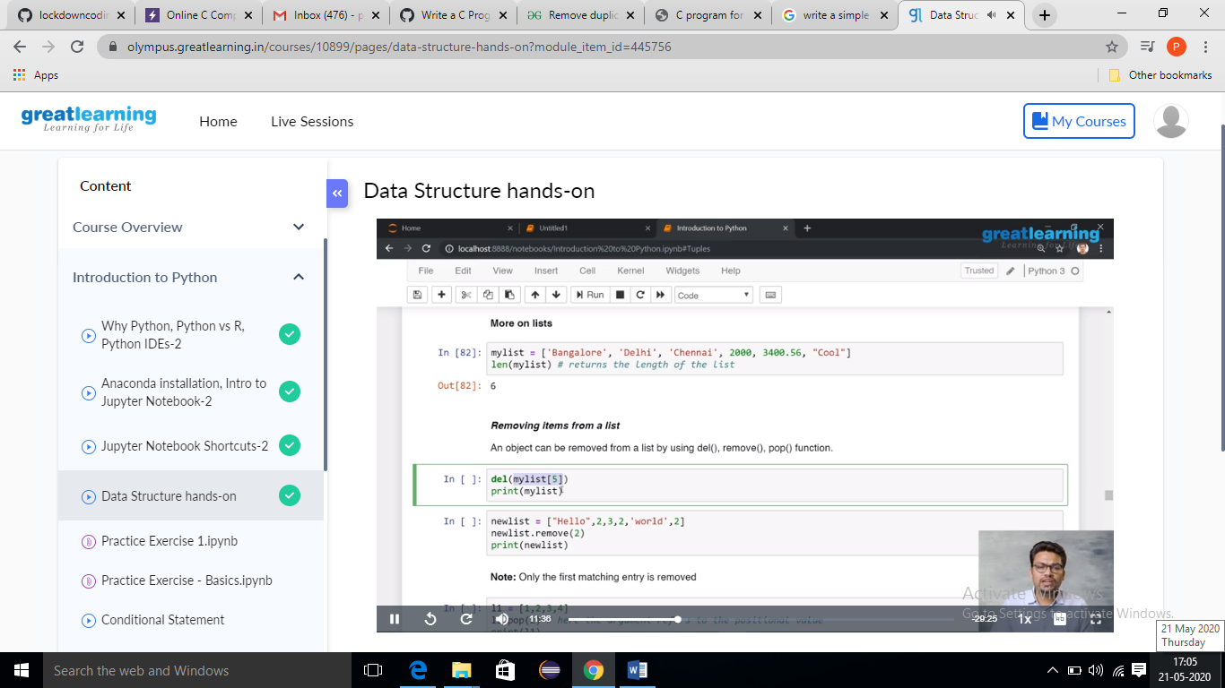

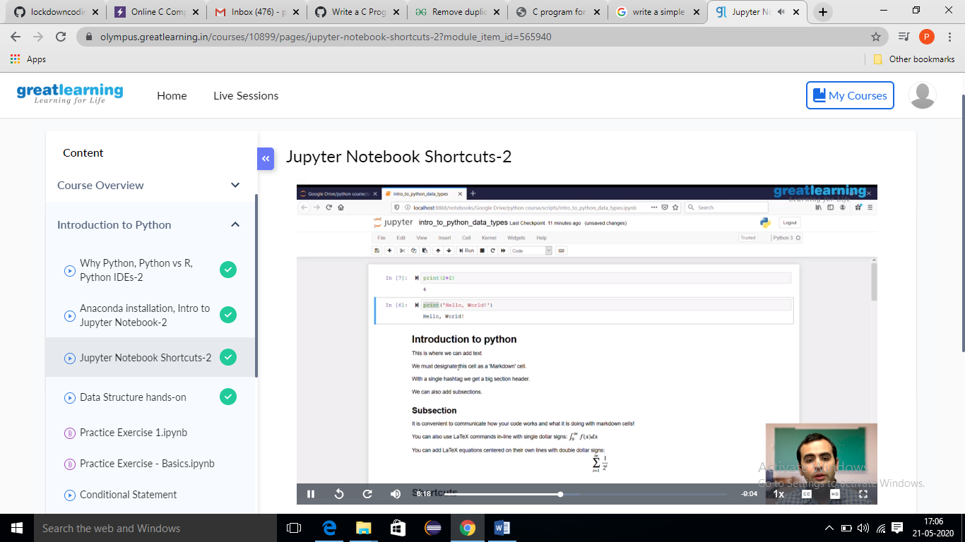

**Online Coding Summary​:** Today I received the first program from prof.Venkatesh CSE Dept, second program was given by prof.Harshitha GM CSE Dept 1)​ ​Write a C Program to Reverse a Linked List (SLL) in groups of given size.​ 2) ​Write a C or Java program to implement FCFS and SJF process scheduling.

